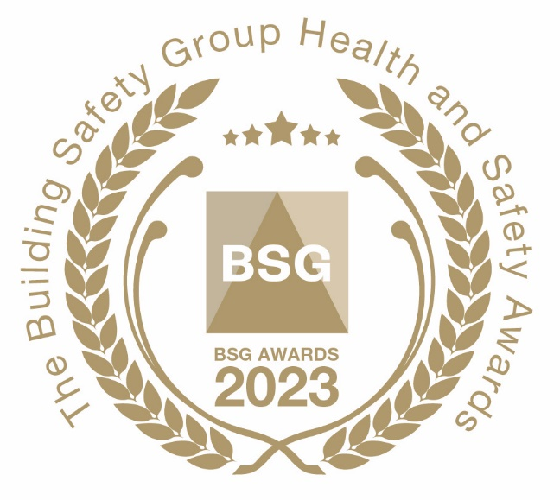
BSG Innovation Award

The BSG Innovation Award will be presented to a company that is best able to demonstrate innovation in its health and safety planning that has led to a demonstrable improvement in risk mitigation and worker well-being. (For example, the ‘innovation’ could describe an instance of how the innovative use of technology, equipment or a process was applied to improve health and safety).

How to submit your nomination

Please answer the following questions to support your entry:

1). Contact information:

Company name: ………………………….. Contact name: ……………………………..

Job title …………………………………….. No. of employees: ………………………...

Tel: no. …………………………………….. Email address: ………………………………..

2). Please describe a recent example of an innovative approach to health and safety taken by your company, identifying the key benefits.

……………………………………………………………………………………………………………

……………………………………………………………………………………………………………

……………………………………………………………………………………………………………

……………………………………………………………………………………………………………

……………………………………………………………………………………………………………

Please supply photographic material to support your nomination as appropriate. There is no word limit for this answer.

Judging Process

BSG’s expert panel of judges will meet to appraise nominations that have been submitted. Members will be notified if their nomination is to be shortlisted for a BSG Award. We will contact your appointed company representative should more information be required about the nomination.

To submit your entry please email this form to: marketing@bsgltd.co.uk

Register to attend the Awards

If you would like to attend the awards please complete and return the registration form on our website:
Awards | BSG (bsgltd.co.uk)
Please note, delegate spaces will initially be restricted to two people per company. More spaces are likely to become available once we gain a clear understanding of how many people are attending.

Priority will be given to member companies that submit a nomination for an award.

