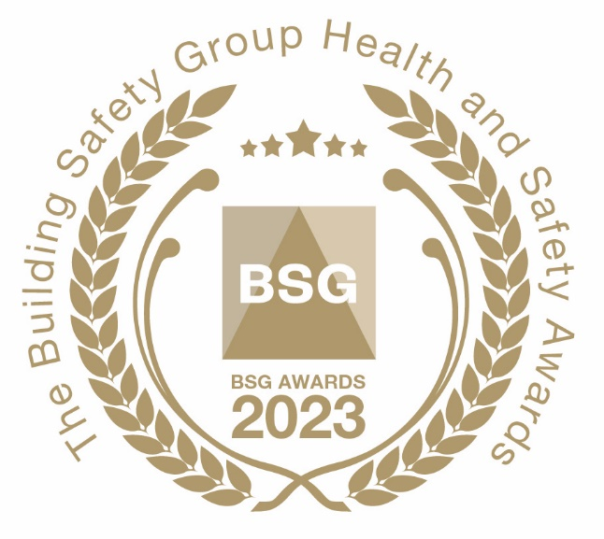
BSG Occupational Health
and Well-being Initiative

The ‘BSG Occupational Health and Well-being Initiative Award’ will be awarded to the BSG member who is best able to demonstrate a recent initiative which will help to prevent and remove Occupational Health risks from the work-pace.

How to submit your nomination

Please answer the following questions to support your entry:

1). Contact information:

Company name: ………………………….. Contact name: …………………………………

Tel: no. …………………………………….. Job title ………………………………………..

Email address: ………………………………..

2). Please provide an example of a system or procedure which has been implemented to prevent and remove Occupational Health risks from the workplace.

……………………………………………………………………………………………………………

……………………………………………………………………………………………………………

……………………………………………………………………………………………………………

……………………………………………………………………………………………………………

……………………………………………………………………………………………………………

Please supply photographic material to support your nomination as appropriate. There is no word limit for this answer.

Judging Process

BSG’s expert panel of judges will meet to appraise nominations that have been submitted. Members will be notified if their nomination is to be shortlisted for a BSG Award. We will contact your appointed company representative should more information be required about the nomination.

To submit your entry please email this form to: marketing@bsgltd.co.uk

Register to attend the Awards

If you would like to attend the awards please complete and return the registration form on our website:
Awards | BSG (bsgltd.co.uk)
Please note, delegate spaces will initially be restricted to two people per company. More spaces are likely to become available once we gain a clear understanding of how many people are attending.

Priority will be given to member companies that submit a nomination for an award.

