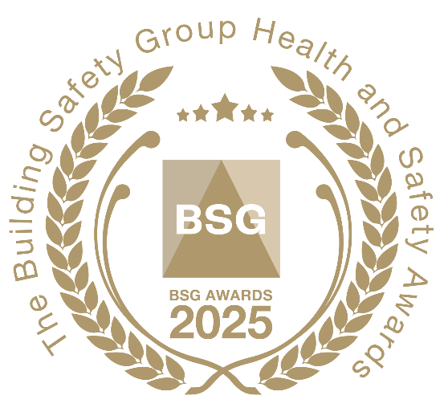

Best Health & Safety Culture

BSG’s **‘Best Health & Safety Culture Award’** will be presented to a member who is able to demonstrate a **responsible** and **positive** attitude towards health and safety at all levels within the business. The winning BSG member must provide evidence of how management has taken a **proactive** approach to health and safety management, where **reporting risks** and hazards is actively encouraged, and the importance of following all OH&S procedures is fully understood.

**How to submit your nomination**

Please answer the following questions to support your entry:

1). Contact information:

Company name: ………………………….. Contact name: ………………………………..

Tel: no. …………………………………….. Job title: ………………………………………

Email address: ………………………………………………………………………………

2). Please describe the health and safety culture within your business and explain why you believe it meets the criteria to win BSG’s ‘Best Health & Safety Culture Award’:

……………………………………………………………………………………………………………

……………………………………………………………………………………………………………

……………………………………………………………………………………………………………

……………………………………………………………………………………………………………

……………………………………………………………………………………………………………

Please supply photographic material to support your nomination as appropriate. There is no word limit for this answer.

**Judging Process**

BSG’s expert panel of judges will meet to appraise nominations that have been submitted. Members will be notified if their nomination is to be shortlisted for a BSG Award. We will contact your appointed company representative should more information be required about the nomination.

To submit your entry please email this form to: [marketing@bsgltd.co.uk](mailto:marketing@bsgltd.co.uk)

Register to attend the Awards

If you would like to attend the awards please complete and return the registration form on our website:

[Awards | BSG (bsgltd.co.uk)](https://www.bsgltd.co.uk/membership/awards-2/)

Please note, delegate spaces will initially be restricted to t**hree** people per company. More spaces are likely to become available once we gain a clear understanding of how many people are attending.

Priority will be given to **member companies** that submit a **nomination** for an award.